DEFINING SLD AND DYSLEXIA USING A PATTERN OF STRENGTHS AND WEAKNESSES IN BASIC PSYCHOLOGICAL PROCESSES AND ACHIEVEMENT
By: Jack A. Naglieri and Steven G. Feifer
Jack A. Naglieri, University of Virginia, is the author of the Cognitive Assessment System- Second Edition.
jnaglieri@gmail.com
www.jacknaglieri.com
11609 Rolling Meadow Drive, Great Falls, VA 22066, 703-975-5477
Steven G. Feifer is the author of the Feifer Assessment of Reading, Feifer Assessment of Math and Feifer Assessment of Writing.
feifer@comcast.net
5805 Iroquois Place, Frederick, MD 21702, 301-606-8038
Abstract
This paper will introduce an approach for the identification and remediation of children with learning disabilities utilizing the Discrepancy Consistency Method (DCM) to detect a Pattern of Strengths and Weaknesses (PSW) across cognitive processing and achievement. We will illustrate how basic psychological processing scores (i.e., PASS scales) from the Cognitive Assessment System – Second Edition (CAS2) are related to specific subtypes of learning disabilities as measured by the Feifer Assessment of Reading (FAR), Feifer Assessment of Math (FAM), and Feifer Assessment of Writing (FAW). The integration of these tools provides a simple, yet powerful, way to uncover a PSW that is consistent with Federal and West Virginia State regulations and, importantly, related to instruction. Selected case studies will be utilized to illustrate how targeted areas of cognitive processing impacts academic achievement so educators can better position themselves to choose targeted intervention strategies to help remediate and/or accommodate key learning skills.

Introduction
Identification of students who have a specific learning disability (SLD) has evolved in recent years from an ability- achievement discrepancy paradigm toward an approach based on a pattern of strengths and weaknesses (PSW) in basic psychological processing and academic skills. Naglieri (1999) first wrote about aligning a student’s scores from tests of psychological processes with the definition of SLD using what he termed the Discrepancy Consistency Method (DCM), most recently described by Naglieri and Otero (2017). Although this conceptual method can be used with most cognitive measures, it has been associated with four basic psychological processes: Planning, Attention, Simultaneous, and Successive or what is commonly referred to as PASS neurocognitive theory and best measured by the Cognitive Assessment System-Second Edition (Naglieri, Das & Goldstein 2014). We chose the PASS theory not only because it has considerable empirical support (see Naglieri & Otero, 2017), but also because it answers the critical questions, “Why does the student struggle?” and most importantly, “What can be done to address the disorder in processing and improve academic functioning?” To answer these questions, it is also critical for examiners to evaluate how specific PASS processes interact with specific academic domains. This is where the Feifer Assessment of Reading (FAR, 2015), the Feifer Assessment of Math (FAM; 2016) and the Feifer Assessment of Writing (FAW, 2020) fit in. These are diagnostic achievement tests used to determine how PASS processes specifically impact reading, math, and written language. By understanding the ways cognitive processing impacts academic achievement, educators can better position themselves to select targeted intervention strategies to help remediate and/or accommodate these skills.
Defining SLD and Dyslexia
The West Virginia Department of Education defines Dyslexia in 34 CFR 300.8(c) (10) as a Specific Learning Disability (SLD), “an alternative term used to refer to a pattern of learning difficulties characterized by problems with accurate or fluent word recognition, poor decoding, and poor spelling ...” The guidelines clearly state that dyslexia is a particular type of a learning disability as defined by West Virginia’s special education regulations. The term SLD is more expansive in nature and refers to “a disorder in one or more of the basic psychological processes involved in understanding or in using language, spoken or written, that may manifest itself in the imperfect ability to listen, think, speak, read, write, spell, or to do mathematical calculations, including conditions such as perceptual disabilities, brain injury, minimal brain dysfunction, dyslexia, and developmental aphasia. SLD does not include learning problems that are primarily the result of visual, hearing, or motor disability, intellectual disability, or emotion/behavioral, or of environmental, cultural, or economic disadvantage.” To meet this definition (which is the same as that used in IDEA), we suggest that assessment of dyslexia should include evaluation of basic psychological processes as well as reading and related skill difficulties despite good instruction.
We propose that it is essential for practitioners in West Virginia to utilize tests capable of delineating the basic psychological processes integral to the definition of SLD and dyslexia to align the methods used for assessment with the state and federal definitions. We further suggest that using PASS neurocognitive scores from the CAS2) along with academic processing scores from the FAM, FAR, and/or FAW provides an ideal way to assess children in concordance with state guidelines, as well as provides the most meaningful interventions. Lastly, the implementation of the DCM to determine SLD inclusive of dyslexia will also guide decision making as to whether direct special education services, targeted academic instruction in general education, or a Section 504 plan is best suited to meet a child’s learning needs. But first we provide the 10 most salient and important reasons to use PASS theory as measured by CAS2 along with the FAR, FAM and FAW.
- The PASS scales on CAS measure thinking (i.e. basic psychological processing) rather than knowing (e.g., vocabulary, arithmetic word problems), making the test very appropriate and less culturally biased for assessment of diverse populations and those with limited educational opportunity.
- PASS scores can be easily obtained in a time efficient manner, requiring 40 minutes (using the 8-subtest Core Battery) or 60 minutes (using the 12-subtest Extended Battery) and scoring and narrative reports are easily derived using online score and report program. Additionally, free PASS and FAR, FAM, and FAW score analyzers are available from www.jacknaglieri.com, along with analyzers for all major achievement tests.
- PASS results are easy to explain to teachers, parents, and the students themselves because the concepts can be explained in non-technical language. That is, the four processing scales measure: how well a student can (a) decide how to solve problems (Planning); focus and resist distractions (Attention); see relationships among things (Simultaneous); (d) and work with information arranged in a sequence (Successive).
- The PASS theory and the CAS2 provide a way to both define and assess ‘basic psychological processes’ so practitioners can obtain scores that are consistent with definition of SLD.
- The PASS scores are strongly correlated to achievement, show distinct patterns of strengths and weaknesses for different populations (e.g., dyslexia, ADHD, autism), are very useful for intervention planning, and provide the most equitable way to measure diverse populations (see Naglieri & Otero, 2017).
- Together, the PASS and FAR/FAM/FAW scores provide excellent evidence of a pattern of strengths and weaknesses in basic psychological process (PASS) and achievement based upon an empirically supported neurocognitive model of learning consistent with brain functioning.
- The FAR, FAM, and FAW have interpretive scoring reports that generate numerous interventions, learning strategies, websites, and apps to assist educators and parents working with children who have specific learning disorders.
- Using the CAS2 in combination with the FAR/FAM/FAW is a much more ecologically sound approach to identify specific psychological processes directly related to the academic skill in question.
- Both the CAS2 and FAR, FAM, or FAW are more cost effective and provide examiners with a timely manner of assessment than standard cross-battery methods that require dozens of assessment tools, and therefore puts far less of a burden on the student.
- Using the CAS2 in combination with the FAR or FAM provides examiners with a more reliable and consistent method to determine SLD identification, especially if utilizing the DCM.

Subtypes of Dyslexia
According to Peterson and colleagues (2013) review of various computational models of reading, both the “dual route” model and the “connectionist” model describe reading deficits as a breakdown in either (1) the phonological assembly of words or (2) the orthographic representation of words or both. This model expands upon the “phonological deficit only” model which had assumed dyslexia as being a homogenous condition, and thus required a homogeneous intervention. In other words, all students received the same phonological instruction program no matter what the reading deficit may entail. The ‘phonological deficit only” model did not account for the developmental trajectory of phonological awareness being more significant with younger than older readers (Araujo et al., 2010; Frijters et al., 2011), and also failed to account why numerous phonological skills are often preserved for disabled readers (Shany & Share, 2011).
A dual route model of reading differentiates between phonological dyslexia, which is a struggle with the “sub-lexical” components of reading with surface dyslexia, which arises from difficulty at the lexical (word) level and impacts speed and fluency. In phonological dyslexia, sequencing individual sounds to recognize the entire printed word form is impaired. Therefore, reading pseudowords are especially difficult for students who have difficulty with the phonological assembly of words because this task places such a high demand on Successive processing from PASS theory. In contrast, children with surface dyslexia struggle at the lexical level and have difficulty with reading fluency and speed. In other words, the orthographic representation of words is compromised, and the student has difficulty taking in the entire printed word form as a Simultaneous whole. These readers tend to have difficulty on phonologically irregular words (i.e. debt, yacht, onion, etc.) because these words cannot be decoded in a sequential manner, and must be recognized as an orthographical unit (Simultaneous processing from PASS theory).
There are three important points when analyzing the interplay between phonological and orthographical processes that children use to recognize the printed word form. First, children at different ages may rely on different cognitive processes at different points of time in their reading development. For instance, younger children tend to rely on phonological processes whereas older children on more orthographic ones (Borleffs et al., 2017). Since the IDA definition of dyslexia reiterates that reading difficulties may entail both accuracy and/or fluency deficits, examiners should assess for both phonological (Successive) and orthographic (Simultaneous) processes. Second, the interplay of orthography and phonology is greatly influenced by the child’s native language. For instance, dyslexics in transparent orthographic systems, such as Spanish, German, Italian, Greek often have more difficulty with reading speed; whereas dyslexics in more opaque languages such as English, struggle more with reading accuracy (Suarez-Coalla et al., 2014). Therefore, the relative contributions of phonology and orthography varies depending upon the demands of the language that a student is reading. Third, knowledge of the semantic value of the word can be a mitigating factor to trigger word recognition that is not accounted for in each model. Therefore, strong vocabulary knowledge can be a compensatory factor that children use to mask weaknesses in a particular psychological process. In other words, it is much easier to use phonological and orthographic processes when there is some familiarity with what the word means, and in what context the word is being read. Consequently, it is incumbent upon examiners to measure psychological processes independent of language skills in order to obtain a more ecologically valid score. The CAS2 provides clinicians with the ability to measure psychological processes in a relatively language free format, and thus should yield a more valid indicator of true performance.

How to Assess for SLD: The Discrepancy Consistency Method (DCM)
Several methods for SLD eligibility determination that includes examining the pattern of strengths and weaknesses (PSW) in academics and cognitive processing have been suggested by Naglieri (1999), Hale and Fiorello (2004), and by Flanagan, Ortiz, and Alfonso (2007). These authors have a similar goal: to present a procedure to detect a PSW in scores (sometimes referred to as a third option; Zirkel & Thomas, 2010) that can be used to identify a student with SLD. Despite differences these authors have in their definition of a basic psychological process and how to determine if a student has a “disorder,” they all rely on finding a combination of discrepancies as well as consistencies in scores. The PSW approach we use is called the Discrepancy Consistency Method (DCM) which we have operationalized with the application of A. R. Luria’s conceptualization of the basic psychological processes.
Naglieri (1999) and Naglieri and Otero (2017) proposed that Luria’s (1973, 1980) description of brain function could be used to define the basic psychological processes referenced in the definition of SLD. There are four basic processes within Luria’s description of functional units. The first is Planning, which provides cognitive control; intentionality; organization; self-monitoring and self-regulation. Planning is associated with the frontal lobes. Attention provides focused, selective, sustained, and effortful activity over time and resistance to distraction and is associated with the brain stem, and targeted cortical areas in the frontal lobes. Simultaneous processing provides the ability to integrate stimuli into a coherent whole, and is usually found on tasks with strong visual-spatial demands and is associated with the occipital-parietal areas of the brain. Finally, Successive processing involves working with stimuli in a specific serial order, including the perception of stimuli in sequence and the linear execution of sounds and movements and is associated with the temporal areas of the brain.
Importantly, it is Successive processing which is the primary cause of difficulties with accurate word recognition, poor phonological, decoding, and spelling skills as well as the resulting diminished reading comprehension problems associated with dyslexia (Naglieri & Otero, 2017). Additionally, Simultaneous processing tends to be the underlying cause of difficulties with text orthography and seeing words as a unique whole, a key process in developing reading fluency. The solution to the dyslexia conundrum is to measure specific psychological processes that underscore both reading accuracy and reading fluency in a manner that is consistent with both state and federal mandates. We will describe and illustrate two case studies in order to demonstrate a theoretically sound and psychometrically strong procedure for defining ‘basic psychological processes’ in state and federal guidelines, and to provide a defensible approach to both identify and remediate students with dyslexia. Furthermore, by providing examiners with a methodology to differentiate between specific subtypes of dyslexia, this should also help drive intervention decision making as well as placement decision making (i.e. Special Education vs. 504 Plan) for children with learning needs.
Determining if a student’s difficulty with word recognition, reading decoding, phonological, and spelling skills is related to a ‘disorder in one or more of the basic psychological processes’ can best be accomplished using the Discrepancy Consistency Method. The presence of dyslexia can be uncovered through analysis of PASS and achievement test scores (assuming the student has had adequate instruction). The method begins with a systematic examination of variability of PASS scores to determine if there is evidence of a PASS cognitive weakness. Naglieri (1999) defined a cognitive weakness as one of the four PASS scores that is significantly lower than the student’s average PASS score and that low score is below normal (typically 1 standard deviation or lower). PASS scores are assessed using the CAS2 (Naglieri, et al., 2014).
The CAS2 can be used as a comprehensive measure of the basic psychological processes necessary for learning, and paired with the Feifer Assessment of Reading (FAR; Feifer, 2015) as a comprehensive measure of academic and linguistic processes used for reading. Together these tests can help determine a child’s learning needs, as well as target specific recommendations. Figure 1 provides an overview of the Discrepancy Consistency Method. For instance, a cognitive weakness on the Successive Scale from the CAS2 would be placed in the lower right side of the triangle. Conversely, good scores, for example on the Planning, Attention, and Simultaneous scales from the CAS2 would be placed in the top portion of the triangle. This provides evidence of a “Discrepancy”, based on variability in PASS processes. Similarly, lower scores on, for example, the Phonological Index of the FAR would be placed in the bottom left triangle, and stronger reading scores on the FAR in the top portion of the triangle. Figure 1 illustrates the discrepancies among the four PASS scores and the differences between PASS and academic scores. Importantly, the “Consistency” portion of the DCM refers to both a clinical and statistical consistency between the lower cognitive score (Successive) and the lower academic process (Phonological Index). For instance, lower Successive processing suggests poor sequential processing of information, and lower scores on the Phonological Index suggests poor sequencing of sounds. This set of data provides evidence for dyslexia characterized by poor processing and academic difficulty. The values needed for significance when making all these comparisons are provided by Naglieri and Otero, in their book Essentials of CAS2 Assessment. PASS and achievement test score analyzers are provided at no cost on www.jacknaglieri.com.

Reading and Dyslexia Case Studies
Case 1- Phonological Dyslexia.
Jacob is an 8-year-old 3rd grade student currently attending White Oak Elementary School. He was referred for a comprehensive psychological evaluation due to concerns regarding his poor reading progress, difficulty with decoding skills, and failure to respond to targeted interventions.

Table 1. Jacob’s Cognitive Assessment System Second Edition (CAS2) and Feifer Assessment of Reading Results.

CAS2 | Standard Score | Percentile Rank | Qualitative Descriptor
Planning | 92 | 30% | Average
Attention | 98 | 45% | Average
Simultaneous | 90 | 25% | Average
Successive | 72 | 3% | Very Low
Full Scale* | 86 | 18% | Below Average
FAR
Phonological Index | 75 | 5% | Moderately Below Average
Fluency Index | 92 | 30% | Average
Mixed Index | 81 | 10% | Below Average
Comprehension Index | 97 | 42% | Average
FAR Total Index* | 84 | 14% | Below Average

CAS2 Scores: Jacob earned Average scores on the Planning, Attention, and Simultaneous processing scales, although a significant weakness was observed on the Successive processing scale. This suggested difficulty remembering information in a serial order, as well as sequencing symbols when problem solving. Successive processing is very important for academic tasks such as decoding words when reading, sounding out words when spelling, and remembering the algorithm or series of steps when solving longer math equations.
FAR Scores: Jacob’s overall FAR Total Index was 86, which was in the Below Average range of functioning, and at the 14th percentile compared to peers. A significant weakness was observed on the Phonological Index, as he scored 75, which was in the Moderately Below Average range and at the 5th percentile compared to peers. His phonemic awareness skills were very inconsistent, as he struggled to blend, segment, and manipulate sounds in words. Jacob also had difficulty when applying decoding skills to both familiar and unfamiliar words in isolation. His passage comprehension skills were a relative strength. Using the Discrepancy Consistency Method, Jacob presented the academic and cognitive processing profile of a student with Phonological Dyslexia.
Figure 2. Jacob
Case 2- Orthographic Dyslexia: Nelson is a 4th grade student attending Stoney Brook Elementary School. He has been receiving targeted academic interventions since 1st grade due to early reading difficulty, poor work completion, and difficulty with spelling and written language skills. He has continued to struggle keeping pace with his peers and often failed to complete his work in a timely manner.
CAS2 Scores: Nelson earned Average scores on the Planning, Attention, and Successive processing scales, however, a significant weakness was found on the Simultaneous processing scale. This scale measures the ability to work with information that is organized into groups and requires an understanding of how shapes, as well as words and verbal concepts, are inter-related. Lower Simultaneous processing can directly hinder a variety of academic skills such as spelling (difficulty conjuring up a visual spatial image of a word), reading fluency (poor text orthography), and mathematics (visualizing amounts).
Table 2. Nelson’s Cognitive Assessment System Second Edition (CAS2) and Feifer Assessment of Reading Results.
CAS2 | Standard Score | Percentile Rank
Planning | 94 | 34%
Attention | 98 | 45%
Simultaneous | 74 | 4%
Successive | 90 | 25%
Full Scale* | 89 | 23%
FAR
Phonological Index | 90 | 25%
Fluency Index | 73 | 4%
Mixed Index | 81 | 10%
Comprehension Index | 97 | 42%
FAR Total Index* | 84 | 14%
*Note: Full Scale and Total Index scores on the CAS2 and FAR, respectively, have limited utility because they do not represent the variability of the scores these tests include.

FAR Scores: Nelson’s overall FAR Total Index was 84, which was in the Below Average range of functioning, and at the 14th percentile compared to peers. A significant weakness was observed on the Fluency Index, as he scored 73, which was in the Moderately Below Average range and at the 4th percentile compared to peers. He worked slowly and laboriously when rapidly identify letters, struggled on most orthographic processing tasks, and was very inconsistent when reading a list of phonologically irregular words. In summary, Nelson’s poor Simultaneous processing abilities are manifested in reading by his struggles with text orthography and difficulty processing the entire printed word form as a unique whole, thereby rendering him more of a sound-by-sound or letter-by-letter reader. Using the Discrepancy Consistency Method. Nelson presented the academic and cognitive processing profile of a student with orthographic dyslexia.
Figure 3. DCM Method for Nelson

Written Language:
The Feifer Assessment of Writing (FAW) is a diagnostic achievement test that examines the underlying cognitive, motoric, and linguistic processes that supports proficient written language skills. This measure follows in the heels of the Feifer Assessment of Reading (FAR, 2015) and Feifer Assessment of Math (FAM, 2016), and completes the suite of diagnostic achievement test batteries designed to examine subtypes of learning disabilities from a brain-behavioral perspective. The FAW measures three subtypes of written language disorders or “dysgraphia” in children. The first subtype is termed “Graphomotor Dysgraphia” and measures a student’s ability to plan, sequence, and execute the physical stroke of the writing process during timed conditions. The PASS processes most sensitive to the motoric aspect of writing are Planning the motor stroke, as well as Successive processing to execute the motor stroke by sequencing multiple letters together. The second written language subtype is deemed “Dyslexic Dysgraphia” and measures the extent to which developmental dyslexia may be impacting writing by wreaking havoc on the spelling process. As previously discussed, the PASS processes critical to effective spelling are Simultaneous processing, which allows students to visualize the entire printed word form in the mind’s eye, as well as Successive processing, which allows students to sequence multiple sounds together to facilitate spelling. In other words, effective spelling requires the ability to visualize or see the word (Simultaneous) while also being able to sound out the individual phonemes as well (Successive). The final written language subtype is termed “Executive Dysgraphia” and refers to specific frontal lobe functions concomitant to the writing process such as planning and sequencing, retrieval fluency, working memory, and saliency determination. In essence, all four PASS processes are deemed critical to plan and sequence our internal thoughts and ideas, while also maintaining attention and resisting distractions when delivering these thoughts and ideas on paper. Table 3 provides a summary of the three different subtypes of writing deficits, in addition to the underlying PASS processes as measured by the CAS2.
Table 3. Writing Subtypes as Measured by the FAW and PASS Processes

Writing Subtype | Description | PASS Process
Graphomotor  Dysgraphia | Measures a student’s ability to plan, sequence, and execute the physical stroke of the writing process during timed conditions. | Planning and Successive
Dyslexic  Dysgraphia | Measures the extent to which developmental dyslexia may be impacting writing by hindering the spelling process. | Simultaneous and Successive
Executive  Dysgraphia | Refers to specific frontal lobe or executive functions in the writing process such as planning and sequencing, retrieval fluency, working memory, and saliency determination. | Planning, Attention  Simultaneous Successive

Case Study-3 Executive Dysgraphia: Elena was referred for a comprehensive psychological evaluation due to concerns regarding her overall written language skills, periodical lapses with her memory, and inconsistent educational progress. She was reported as not meeting grade level standards in both language arts and mathematics, and her grades have consisted of mainly C’s and D’s. Elena was reported by her teacher as struggling to organize her thoughts and ideas into meaningful paragraphs when writing, was somewhat impulsive in her manner, and had difficulty sustaining and focusing her attention during more lecture-oriented activities. She was also prone to make careless mistakes in her daily work.

CAS2 Scores: Elena’s overall CAS2 Full Scale score was 86, which was in the Below Average range and 18th percentile compared to peers. However, there was much variability noted among her PASS profile of scores. She earned Average scores on tasks measuring Simultaneous processing, but greatly struggled on the Planning, Attention and Successive processing scales, scoring in the Below Average range on each. Lower scores with Planning and Attention are often seen among students with ADHD and impulse control difficulty. In addition, these students also tend to be prone toward making careless miscues in her work. With respect to written language, poor Planning suggests an inability to properly organize thoughts and ideas, while poor Attention suggests an inability for Elena to hold on to her thoughts and ideas long enough to deliver them on paper without being distracted. Lastly, poor Successive processing suggests difficulty sequencing information and separating thoughts and ideas by way of topic sentences, transitional words, and paragraph breaks.
Table 4. Elena’s PASS and Full Scale Scores From the CAS2
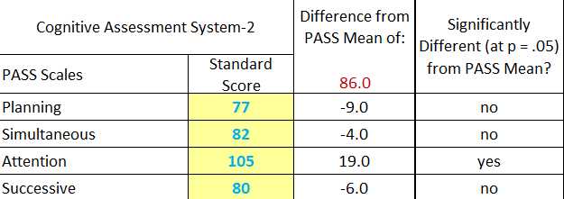
FAW Scores: Elena’s FAW Total Index Score was 87, which was in Below Average range and at the 19th percentile compared to peers. Her Executive Dysgraphia Index score was a relative weakness, as she scored 76, which was in the Moderately Below Average range and at the 5th percentile compared with her peers. Lower scores on the Executive Dysgraphia Index suggests difficulty on a wide range of written language skills including weaknesses with planning, organizing, retrieving, and/or sequencing thoughts and ideas to produce a written response. In addition, students with executive dysgraphia often do not elaborate on their writing, and tend to make numerous spelling and grammatical miscues. Elena had significant difficulty sequencing her thoughts and ideas during most language related tasks (Sentence Scaffolding=5). She was especially inconsistent on a task that involved writing an essay (Expository Writing Index =6). Elena did not always elaborate on her thoughts and ideas, was prone to careless miscues, and her writing lacked much organization and flow. Most sentences were rather simplistic and redundant, with little variety noted. In addition, she did not utilize an effective topic sentence to initiate her essay. Using the Discrepancy-Consistency model, Elena presented the profile of a student with Executive Dysgraphia.
Table 5. FAW Results for Elena
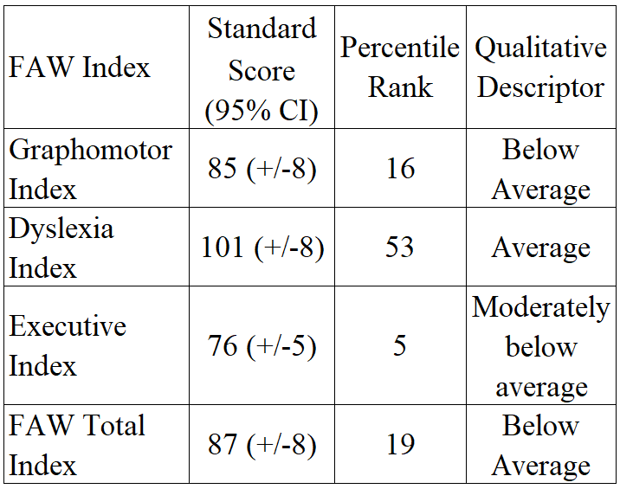

Mathematics:
The Feifer Assessment of Mathematics (FAM) is a comprehensive test of mathematics designed to examine the underlying neurodevelopmental processes that support the acquisition of proficient math skills. The FAM measures three subtypes of math disorders in children. The verbal subtype refers to children who have difficulties with rapid number identification skills, and deficits retrieving or recalling stored mathematical facts in an automatic fashion. In essence, the verbal subtype of dyscalculia represents a disorder of the verbal representations of numbers, and the inability to use language-based procedures to assist in arithmetic fact retrieval skills. The procedural subtype represents one or more deficits in the ability to count, order, or sequence numbers and/or sequencing mathematical procedures (e.g., remembering the algorithm) when problem solving. The procedural subtype not only underscores serial counting, but also is involved in recalling the sequences of steps necessary to perform multi-digit tasks such as long division, multiplying or dividing multi-digit numbers, as well as working with fractions and decimals. The third subtype of dyscalculia is referred to as the semantic subtype, which is an inability to conceptually understand mathematics and often consists of visual-spatial deficits. A core deficit is an inability to decipher magnitude representations among numbers. The semantic subtype represents a break down in higher level mathematical problem solving, or quantitative reasoning, that is often due to poor visual-spatial synthesis of mathematical information. Table 6 provides a summary of the three different subtypes of mathematical learning deficits, in addition to the PASS processes underscoring each subtype.

Table 6. Math Subtypes as Measured by the FAM and PASS Processes
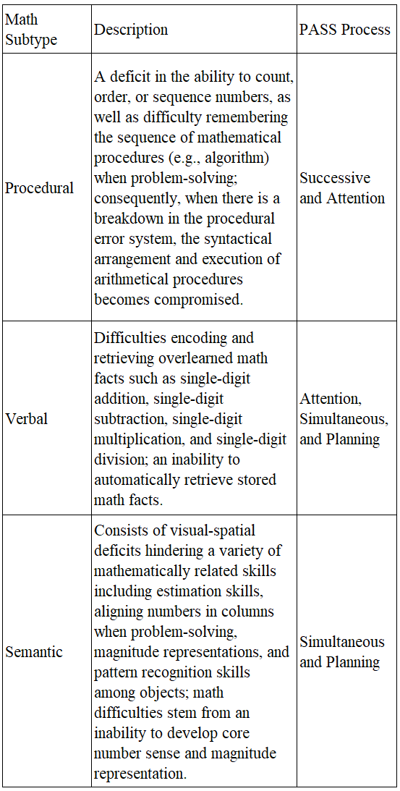

Case Study 4: Semantic Dyscalculia: William is a fourth-grade student whose rambunctious and playful personality has often led to academic and behavioral pitfalls in class. Though quite popular with peers, he tends to have a rather impulsive response style when problem-solving and often dives into an assignment with no particular strategy or plan. For example, take a math word problem involving rate, time, and distance, when there is often too much information embedded within the problem. William often chooses the first numeral or data point presented in a hurried fashion and usually selects the wrong algorithm (strategy) to solve the problem. Planning, which is the essence of good executive functioning, is a necessary prerequisite for deciding “what to do when” and is very important when solving mathematical problems.

CAS2 Scores: William’s CAS2 Full Scale score was 92, which was in the Average range and in the 30th percentile compared to peers. Because this score reflects a combination of PASS processing strengths and weaknesses, emphasis should be placed on the separate PASS scores, which vary considerably. For instance, his Simultaneous and Successive processing scores were in the Average range; however, William has cognitive weaknesses on the Planning and the Attention scales, which lead to poor control of thinking and little use of strategies to focus attention and resist distractions. In fact, lower scores in Planning and Attention are typical for students with attention-deficit hyperactivity disorder, and can be described as a problem with executive functioning as well.

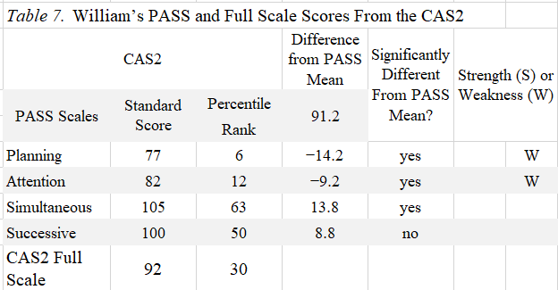

FAM Scores: William’s overall FAM Total Index score was also 92, which was in the Average range and at the 30th percentile compared to peers. This case illustrates how overall scores can be misleading because his overall FAM index score was consistent with his CAS2 Full Scale score. However, he clearly has specific weaknesses in the Semantic Index, as he scored 79, which was in the Moderately Below Average range and only at the 8th percentile compared to peers. Lower scores on this index often suggests poor quantitative reasoning and number sense, and difficulty applying mathematical skills to solve real-world problems.
The DCM provides educators a way to conceptualize the relationships between the specific PASS processing weaknesses, and academic weaknesses to arrive at an accurate diagnosis. William makes careless mistakes due to impulsive problem-solving, which is most likely reflective of ADHD and is related to poor Planning and Attention. William should meet IDEIA criteria as a student with an SLD using the DCM and a PSW model. Once the disorder in basic psychological processing is established, then specific interventions can be considered. For example, instructional modification may include color-coding math operational signs as well as color-coding important vocabulary terms embedded within word problems in order to trigger more consistent decision making.
Table 8. FAM Results for William
FAM Index | Standard  Score (95% CI) | Percentile Rank | Qualitative Descriptor
Procedural Index | 96 (+/-8) | 39 | Average
Verbal Index | 101 (+/-8) | 53 | Average
Semantic Index | 79 (+/-5) | 8 | Moderately below average
FAM Total Index | 92 (+/-8) | 30 | Average

References

Araújo, S., Pacheco, A., Faísca, L., Petersson, K. M., & Reis, A. (2010). Visual rapid naming and phonological abilities: Different subtypes in dyslexic children. International Journal of Psychology, 45, 443-452.
Borleffs, E., Maassen, B. A. M., Lyytinen, H., & Zwarts, F. (2017). Measuring orthographic
transparency and morphological-syllabic complexity in alphabetic orthographies: a
narrative review. Reading-Writing, 30(8), 1617-1638.
Feifer, S. G. & Gerhardstein, R. N. (2015). Feifer Assessment of Reading (FAR). Lutz, FL: PAR.
Feifer, S. G. & Clark, H. K. (2016). Feifer Assessment of Math (FAM). Lutz, FL: PAR.
Feifer, S. G. (2016). Feifer Assessment of Writing (FAW). Lutz, FL: PAR.
Frijters, J. C., Lovett, M. W., Steinbach, K. A., Wolf, M., Sevcik, R. A., & Morris, R. D. (2011). Neurocognitive predictors of reading outcomes for children with reading disabilities. Journal of Learning Disabilities, 44, 150-166.
Hale, J. B., & Fiorello, C. A. (2004). School neuropsychology: A practitioner’s handbook. New York: Guilford Press.
Flanagan, D. P., Ortiz, S. O., & Alfonso, V. C. (2007). Essentials of Cross-Battery Assessment with C/D ROM (2nd Ed.). New York: John Wiley.
Luria, A. R. (1973). The working brain: An introduction to neuropsychology. New York, NY: Basic Books.
Luria, A. R. (1980). Higher cortical functions in man (2nd ed.). New York, NY: Basic Books.
Naglieri, J. A. (1999). Essentials of CAS assessment. Hoboken, NJ: Wiley.
Naglieri, J. A., Das, J. P. & Goldstein, S. (2014). Cognitive Assessment System – Second Edition. Austin, TX: ProEd.
Naglieri, J. A. & Otero T. M. (2017). Essentials of CAS2 assessment. Hoboken, NJ: Wiley.
Peterson, R. L., Pennington, B. F., & Olson, R. K. (2013). Subtypes of developmental dyslexia: Testing the predictions of the dual-route and connectionist frameworks. Cognition, 126(1), 20-38.
Shany, M., & Share, D. L. (2011). Subtypes of reading disability in a shallow orthography: A double dissociation between accuracy-disabled and rate-disabled readers of Hebrew. Annals of Dyslexia, 61, 64-84.
Suarez-Coalla, P., Avdyli, R., & Cuetos, F. (2014). Influence of context-sensitive rules on the formation of orthographic representations in Spanish dyslexic children. Frontiers in Psychology, Dec 4;5:1409.
Zirkel, P. A., & Thomas, L. B. (2010). State laws for RTI: An updated snapshot. Teaching Exceptional Children, 42, 56-63.

